Home Page Config Agilix Data Structure
Table of Contents
Tabs and Content Links 2
Managing Tabs and Contents Links 3
Edit Mode 3
Unlocking 4
Tab Visibility 6
Widgets. 7
Unlocking 7
Adding a Widget 7
Action buttons. 8
Sequence 8
Custom Widgets 9
Creating a Custom Widget 9
Widget Creation In Code 11
Adding a widget to your Home Page. 13
Appendix 16
Content Tab 17
My Assignments 19
My Gradebook and Scorecard 20
My ePortfolio 21
My Bookmark 23
My Bookcover [image] 24
My Writing Assignment 25
Zones: PX_LOCATION_ZONE1, PX_LOCATION_ZONE2, PX_LOCATION_ZONE3 26
Toc Widget 27
Quick Panel Widget 28
Quick Panel Widget 30
Content Read Widget 31
Assignments Widget 33
Announcement Widget 35
Progress Widget 37
Featured Content Widget 39
Custom Widget 42

Tabs and Content Links
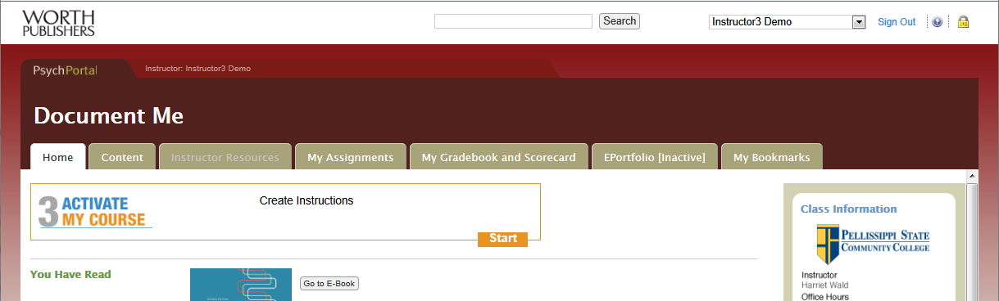

The Tabs at the top of each page represents an easy form navigation. Each tab is a direct representation of an Agilix item. The Tabs themselves exist in a parent folder called PX_LOCATION_ZONE1. Tabs such as Content, My Assignments, Grade book and Score and ePortfolio and My Bookmarks have special visibility behavior in PX. This behavior is keyed off of the “ExtendedLinkType” property. For example the “My Writing” tab is only shown to Students.

- Below is a Brain Honey representation of Zone 1 and some sub items.

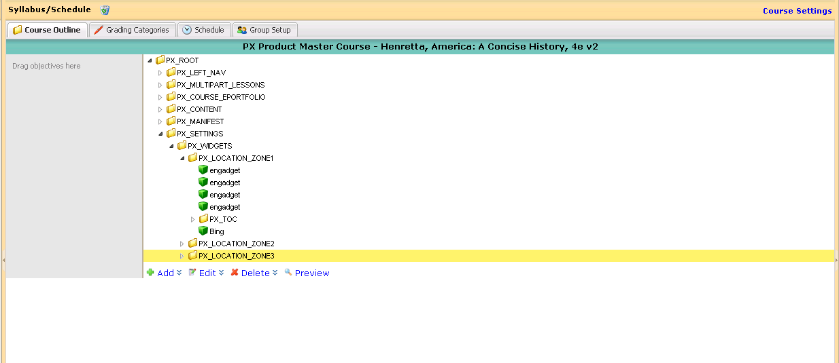

Managing Tabs and Contents Links

Edit Mode

Create a new Course, any Tab created on the Product course will automatically be inherited and will appear on the derived Course.
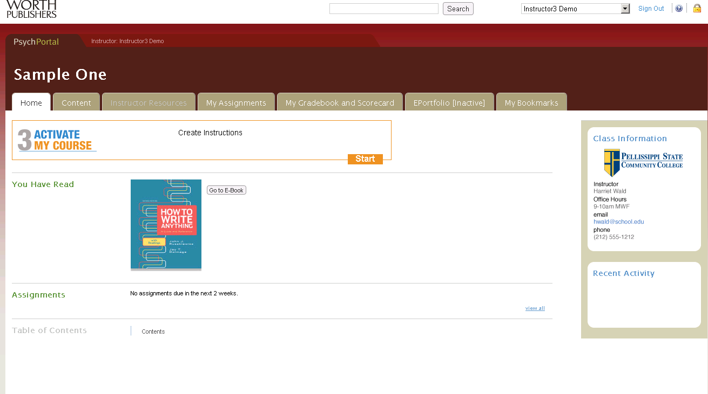

Unlocking

To enter the “Edit” mode simply Click the Lock icon in the upper right hand corner.
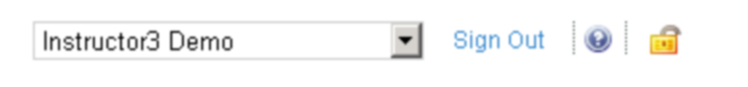

- And this is what the Home Page looks like in Edit Mode.

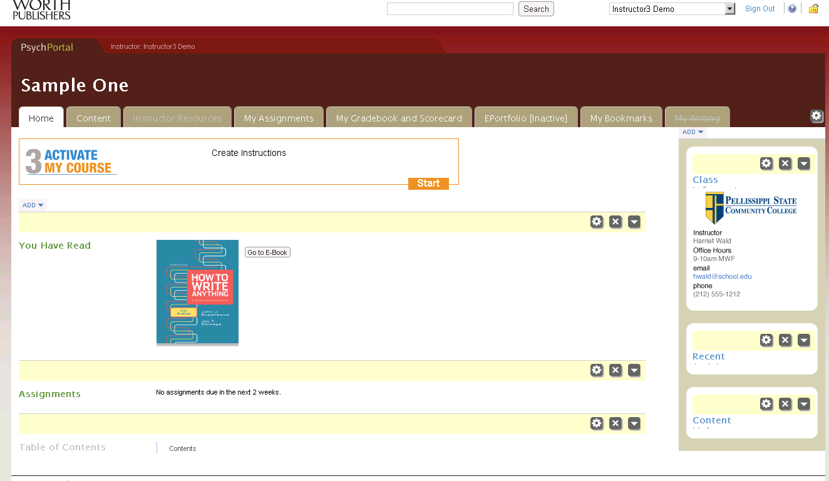

By clicking the gearbox to the right of the Tabs area we are able to manage the tabs.

- At this point we are able to Add/Edit/Remove tabs on the screen below.
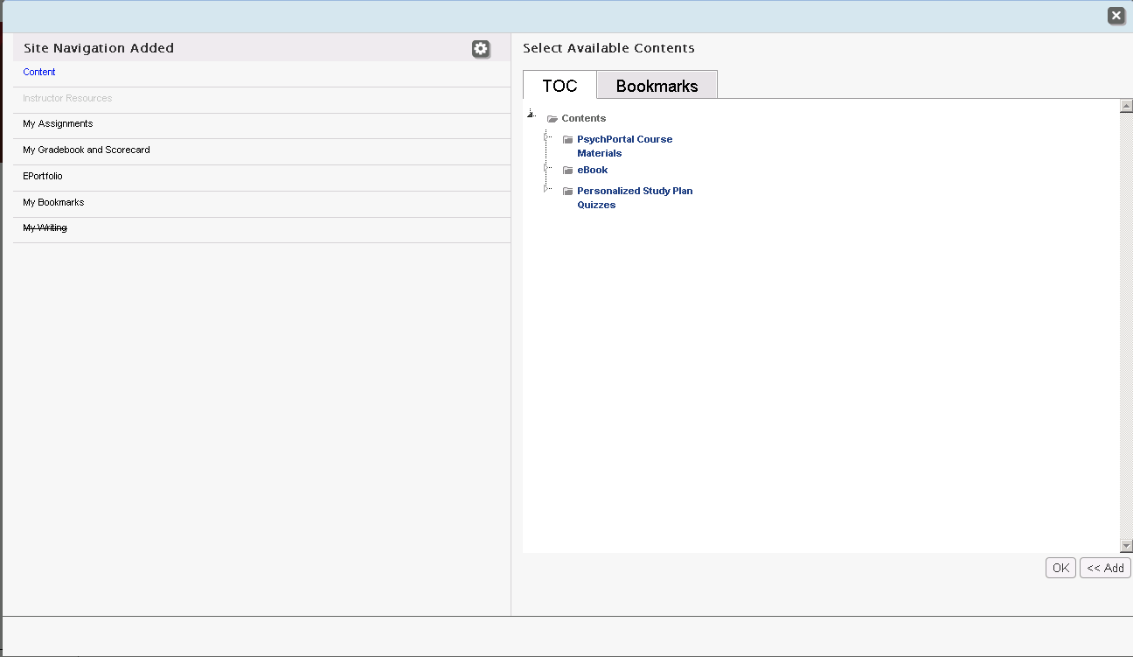

Tab Visibility
We are also able to manage a Tab’s visibility on this screen as.
- Hide from Student: Tab will not appear for Students.
- Hide: Tab will not appear for Instructors except in “Edit Mode”.
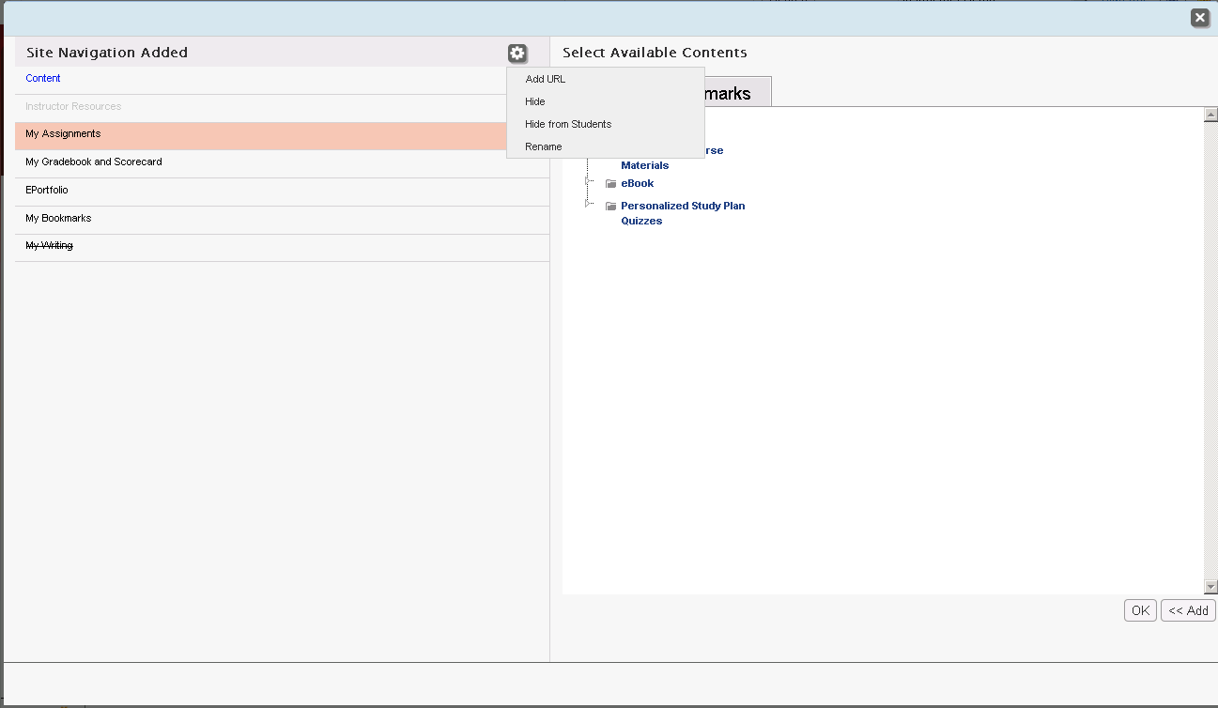

Widgets.

Unlocking
To enter the “Edit” mode simply Click the Lock icon in the upper right hand corner.

Adding a Widget

By clicking on the “Add” link we are presented with a drop down list of available Widgets to add. The check box next to the Widget’s name indicates where it has already been added. Simply clicking the check will either add or remove a Widget depending on if it is already added or not.

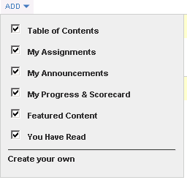

Action buttons.
- With the gearbox we are able to manage Visibility
- Remove a Widget from use.
- Minimize/Expand a Widget for all further use.
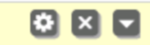

Sequence
- We are able to adjust the sequence of a Widget by dragging and dropping it in relation to it’s siblings.

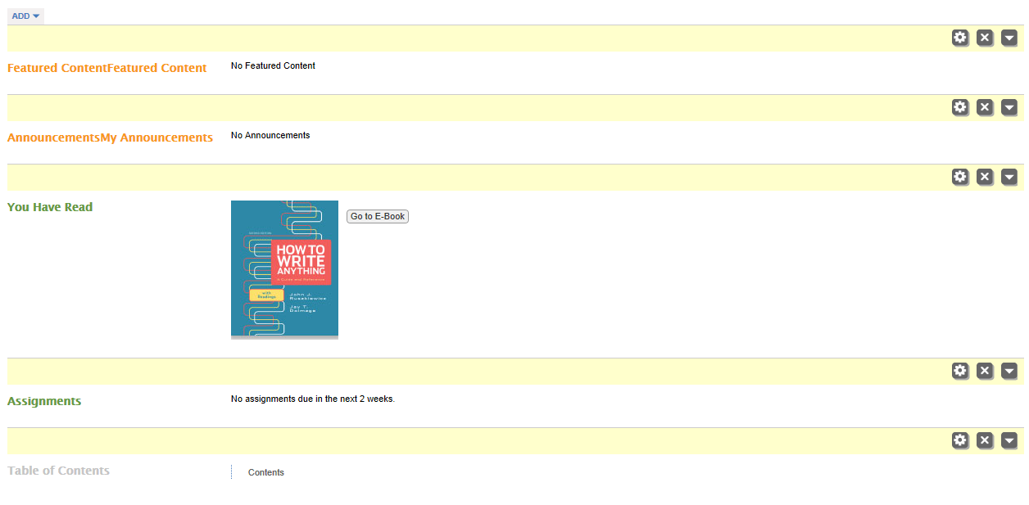

- Widgets are stored in PX_LOCATION_ZONE2. A widget consists of 2 parts.

Part 1. Is the configuration file which is an Agilix item with the following attributes that allow us to generate a Widget Object?
- bfw_type of “WidgetConfiguration”.
- Property of bfw_controller
- Property of bfw_action.

Custom Widgets

Creating a Custom Widget

Follows the same steps as “Adding a widget” but selecting “Creating your own”.

We are then presented with a screen that will allow us to enter our Custom Widget’s Title and the contents to display.

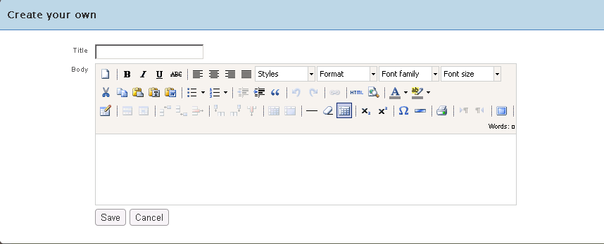

A Custom Widget consists of two parts

Part 1: Is the Config File which functions in the exact manner as a regular widget. The key properties are the bfw_controller and bfw_action. From this we can instantiate a PX Widget. In this case the Controller name is CustomWidget. You will also notice the ID of the custom widget; this is the ID of the associated file where the HTML data is stored.

Part 2: The data for the Custom Widget is stored in an HTML document. As mentioned about the IDs are kept in sync.

Widget Creation In Code

- Implement the IPXWidget interface and derive from the Controller base Class.

public class MySampleWidgetController : Controller, IPXWidget

public interface IPXWidget
{
/// <summary>
/// Action providing the display of the widget when it is in 'Summary' mode.
/// </summary>
/// <returns></returns>
ActionResult Summary ();
- This is the HTML to be displayed. Usually a View or just the raw HTML

/// <summary>
/// Action providing the display of the widget when it is in 'View All' mode.
/// </summary>
/// <returns></returns>
ActionResult ViewAll();

}

- Ensure that the Configuration file has the correct name of the Controller and Action method.
- Set the bfw_controller property to “MySampleWidgetController”
<item id="custom_widget_fe8b212ee64042b187379843b0804421" version="0.0.5" resourceentityid="5570,1,1,11" actualentityid="5570" creationdate="2011-05-02T22:20:17.61Z" creationby="48" modifieddate="2011-05-02T22:49:34.113Z" modifiedby="48" origindepth="2" derivativedepth="2">
<data>
<parent>PX_LOCATION_ZONE2</parent>
<title>My Widget</title>
<folder>custom_widget_fe8b212ee64042b187379843b0804421</folder>
<category>0</category>
<bfw_properties>
<bfw_property name="bfw_visibility" type="String"><bfw_visibility /></bfw_property>
<bfw_property name="bfw_syllabusfilter" type="String"/>
<bfw_property name="bfw_type" type="String">WidgetConfiguration</bfw_property>
<bfw_property name="bfw_controller" type="String"> MySampleWidgetController </bfw_property>
<bfw_property name="bfw_action" type="String">Summary</bfw_property>
<bfw_property name="bfw_cssclass" type="String"/>
<bfw_property name="bfw_viewallfne" type="String">false</bfw_property>
<bfw_property name="bfw_iscollapsed" type="Boolean">false</bfw_property>
<bfw_property name="bfw_isviewallsupported" type="Boolean">true</bfw_property>
</bfw_properties>
<bfw_tocs>
<bfw_toc_contents parentid="PX_LOCATION_ZONE2" sequence="a"/>
</bfw_tocs>
</data>
</item>

Appendix

Content Tab
Agilix
ItemId | - The Content tab should always have the fixd Id of "PX_LOCATION_ZONE1_MENU0_CONTENT". The Content Tab has different behavior because is time to the TocId.
Parent | - “PX_LOCATION_ZONE1_MENU0” this represents the Parent Folder.
Sequence | - Represents it place amongst it’s sibling.
Gradable | - Not applicable.
Category | - Not applicable.
BFW_Properties
bfw_Type | “NavigationItem” which content item to make this Agilix item to.
bfw_TocId | Used when building the URL to the Content Browser page.
bfw_Visibility | - Possible values (<student/> <instructor/>). Indicates who has right to see this piece of content.
Highlighted | Not Applicable.
bfw_isfne | - Bool representing if to show the URL in FNE.
bfw_issupportaddlink | Bool representing if to allow adding links.
- bfw_isdisplaytitle | Indicates whether to show Title or not
- bfw_displaytitle | The Title to display
XML
<item itemid="PX_LOCATION_ZONE1_MENU0_CONTENT" entityid="9">
<data>
<parent>PX_LOCATION_ZONE1_MENU0</parent>
<sequence>_k</sequence>
<title>CONTENT</title>
<folder>PX_LOCATION_ZONE1_MENU0_CONTENT</folder>
<category>0</category>
<gradable>true</gradable>
<bfw_type>NavigationItem</bfw_type>
<bfw_properties>
<bfw_property name="bfw_visibility" type="String"><bfw_visibility> <student /> <instructor /> </bfw_visibility></bfw_property>
<bfw_property name="highlighted" type="Boolean">false</bfw_property>
<bfw_property name="bfw_istoplevel" type="Boolean">false</bfw_property>
<bfw_property name="bfw_isactive" type="Boolean">true</bfw_property>
<bfw_property name="bfw_tocid" type="String">bsi__C11A9126__DBC9__407E__B4CB__5E9968F9844F</bfw_property>
<bfw_property name="bfw_isfne" type="Boolean">false</bfw_property>
<bfw_property name="bfw_titleurl" type="String"/>
<bfw_property name="bfw_issupportaddlink" type="Boolean">true</bfw_property>
<bfw_property name="bfw_issupportaddmenu" type="Boolean">false</bfw_property>
<bfw_property name="bfw_isdisplaytitle" type="Boolean">false</bfw_property>
<bfw_property name="bfw_displaytitle" type="String">CONTENT</bfw_property>
</bfw_properties>
<bfw_tocs>
<bfw_toc_contents parentid="PX_LOCATION_ZONE1_MENU0" sequence="_k"/>
</bfw_tocs>
</data>
</item>

My Assignments
Agilix
ItemId | - A unique Id.
Type | - CustomActivity The agilix base type used to represent this object.
Parent | - “PX_LOCATION_ZONE1_MENU0” this represents the Parent Folder.
Sequence | - Represents it place amongst it’s sibling.
Gradable | - Not applicable.
Category | - Not applicable.
Folder | - The Agilix folder used for resource mapping.
Title | - Text to display for the Title
BFW_Properties
bfw_extendedlinktype | “Assignment” there is logic in PX that determines visibility based on the extendedlink type.
bfw_toc_contents | The parent folder
bfw_Visibility | - Possible values (<student/> <instructor/>). Indicates who has right to see this piece of content.
XML
<item itemid="757c880283194b37b632bed74082684c" entityid="9">
<data>
<type>CustomActivity</type>
<parent>PX_LOCATION_ZONE1_MENU0</parent>
<sequence>_l</sequence>
<title>My Assignments</title>
<folder>757c880283194b37b632bed74082684c</folder>
<category>0</category>
<bfw_type>Link</bfw_type>
<bfw_properties>
<bfw_property name="bfw_visibility" type="String"><bfw_visibility> <instructor /> <student /> </bfw_visibility></bfw_property>
<bfw_property name="bfw_extendedlinktype" type="String">Assignment</bfw_property>
</bfw_properties>
<bfw_tocs>
<bfw_toc_contents parentid="PX_LOCATION_ZONE1_MENU0" sequence="_l"/>
</bfw_tocs>
</data>
</item>

My Gradebook and Scorecard
Agilix
ItemId | - A unique Id.
Type | - CustomActivity The agilix base type used to represent this object.
Parent | - “PX_LOCATION_ZONE1_MENU0” this represents the Parent Folder.
Sequence | - Represents it place amongst it’s sibling.
Gradable | - Not applicable.
Category | - Not applicable.
Folder | - The Agilix folder used for resource mapping.
Title | - Text to display for the Title
BFW_Properties
bfw_extendedlinktype | “MyGradebookandScorecard” there is logic in PX that determines visibility based on the extendedlink type
bfw_toc_contents | The parent folder
bfw_Visibility | - Possible values (<student/> <instructor/>). Indicates who has right to see this piece of content.
XML
<item itemid="757c880283194b37b632bed74082684c" entityid="9">
<data>
<type>CustomActivity</type>
<parent>PX_LOCATION_ZONE1_MENU0</parent>
<sequence>_l</sequence>
<title>My Assignments</title>
<folder>757c880283194b37b632bed74082684c</folder>
<category>0</category>
<bfw_type>Link</bfw_type>
<bfw_properties>
<bfw_property name="bfw_visibility" type="String"><bfw_visibility> <instructor /> <student /> </bfw_visibility></bfw_property>
<bfw_property name="bfw_extendedlinktype" type="String">Assignment</bfw_property>
</bfw_properties>
<bfw_tocs>
<bfw_toc_contents parentid="PX_LOCATION_ZONE1_MENU0" sequence="_l"/>
</bfw_tocs>
</data>
</item>

My ePortfolio
Agilix
ItemId | - A unique Id.
Type | - CustomActivity The agilix base type used to represent this object.
Parent | - “PX_LOCATION_ZONE1_MENU0” this represents the Parent Folder.
Sequence | - Represents it place amongst it’s sibling.
Gradable | - Not applicable.
Category | - Not applicable.
Folder | - The Agilix folder used for resource mapping.
Title | - Text to display for the Title
BFW_Properties
bfw_extendedlinktype | “Eportfolio” there is logic in PX that determines visibility based on the extendedlink type
bfw_toc_contents | The parent folder
bfw_Visibility | - Possible values (<student/> <instructor/>). Indicates who has right to see this piece of content.
XML
<item itemid="c12561d308ff4bd1be1148fd8e9b1014" entityid="9">
<data>
<type>CustomActivity</type>
<parent>PX_LOCATION_ZONE1_MENU0</parent>
<sequence>_l_la</sequence>
<title>EPortfolio</title>
<folder>c12561d308ff4bd1be1148fd8e9b1014</folder>
<category>0</category>
<bfw_type>Link</bfw_type>
<bfw_properties>
<bfw_property name="bfw_visibility" type="String"><bfw_visibility> <instructor /> <student /> </bfw_visibility></bfw_property>
<bfw_property name="bfw_extendedlinktype" type="String">Eportfolio</bfw_property>
</bfw_properties>
<bfw_tocs>
<bfw_toc_contents parentid="PX_LOCATION_ZONE1_MENU0" sequence="_l_la"/>
</bfw_tocs>
</data>
</item>

My Bookmark
Agilix
ItemId | - A unique Id.
Type | - CustomActivity The agilix base type used to represent this object.
Parent | - “PX_LOCATION_ZONE1_MENU0” this represents the Parent Folder.
Sequence | - Represents it place amongst it’s sibling.
Gradable | - Not applicable.
Category | - Not applicable.
Folder | - The Agilix folder used for resource mapping.
Title | - Text to display for the Title
bfw_type | - The PX object to map to.
BFW_Properties
bfw_extendedlinktype | “BookMark” there is logic in PX that determines visibility based on the extendedlink type
bfw_toc_contents | The parent folder
bfw_Visibility | - Possible values (<student/> <instructor/>). Indicates who has right to see this piece of content.
XML
<item itemid="8403876d694e4477ade730d1da1061ce" entityid="9">
<data>
<type>CustomActivity</type>
<parent>PX_LOCATION_ZONE1_MENU0</parent>
<sequence>_l_m</sequence>
<title>My Bookmarks</title>
<folder>8403876d694e4477ade730d1da1061ce</folder>
<category>0</category>
<bfw_type>Link</bfw_type>
<bfw_properties>
<bfw_property name="bfw_visibility" type="String"><bfw_visibility> <student /> <instructor /> </bfw_visibility></bfw_property>
<bfw_property name="bfw_extendedlinktype" type="String">BookMark</bfw_property>
</bfw_properties>
<bfw_tocs>
<bfw_toc_contents parentid="PX_LOCATION_ZONE1_MENU0" sequence="_l_m"/>
</bfw_tocs>
</data>
</item>

My Bookcover [image]
Agilix
ItemId | - A unique Id.
Type | - CustomActivity The agilix base type used to represent this object.
Parent | - “PX_LOCATION_ZONE1_MENU0” this represents the Parent Folder.
Sequence | - Represents it place amongst it’s sibling.
Gradable | - Not applicable.
Category | - Not applicable.
Folder | - The Agilix folder used for resource mapping.
Title | - Text to display for the Title
BFW_Properties
bfw_extendedlinktype | “Image” there is logic in PX that determines visibility based on the extendedlink type
bfw_toc_contents | The parent folder
bfw_Visibility | - Possible values (<student/> <instructor/>). Indicates who has right to see this piece of content.
XML
<item itemid="e48c04c07c3e4f0e8ea25b24fcea250d" entityid="9">
<data>
<type>CustomActivity</type>
<parent>PX_LOCATION_ZONE1_MENU0</parent>
<sequence>_ma</sequence>
<title>book-cover</title>
<folder>e48c04c07c3e4f0e8ea25b24fcea250d</folder>
<category>0</category>
<bfw_type>Link</bfw_type>
<bfw_properties>
<bfw_property name="bfw_visibility" type="String"><bfw_visibility /></bfw_property>
<bfw_property name="bfw_extendedlinktype" type="String">image</bfw_property>
</bfw_properties>
<bfw_tocs>
<bfw_toc_contents parentid="PX_LOCATION_ZONE1_MENU0" sequence="_ma"/>
</bfw_tocs>
</data>
</item>

My Writing Assignment
Agilix
ItemId | - A unique Id.
Type | - CustomActivity The agilix base type used to represent this object.
Parent | - “PX_LOCATION_ZONE1_MENU0” this represents the Parent Folder.
Sequence | - Represents it place amongst its sibling.
Gradable | - Not applicable.
Category | - Not applicable.
Folder | - The Agilix folder used for resource mapping.
Title | - Text to display for the Title
BFW_Properties
bfw_extendedlinktype | “writting_assignment” there is logic in PX that determines visibility based on the extendedlink type
bfw_toc_contents | The parent folder
bfw_Visibility | - Possible values (<student/> <instructor/>). Indicates who has right to see this piece of content.
XML
<item itemid="4865a560d2aa4339b4f0b14785ad6c49" entityid="9">
<data>
<type>CustomActivity</type>
<parent>PX_LOCATION_ZONE1_MENU0</parent>
<sequence>k</sequence>
<title>My Writing</title>
<folder>4865a560d2aa4339b4f0b14785ad6c49</folder>
<category>0</category>
<bfw_type>Link</bfw_type>
<bfw_properties>
<bfw_property name="bfw_visibility" type="String"><bfw_visibility> <student /> </bfw_visibility></bfw_property>
<bfw_property name="bfw_extendedlinktype" type="String">writting_assignment</bfw_property>
</bfw_properties>
<bfw_tocs>
<bfw_toc_contents parentid="PX_LOCATION_ZONE1_MENU0" sequence="k"/>
</bfw_tocs>
</data>
</item>

Zones: PX_LOCATION_ZONE1, PX_LOCATION_ZONE2, PX_LOCATION_ZONE3
Agilix
ItemId | - A unique Id.
Parent | - “PX_WIDGETS” this represents the Parent Folder.
Title | - Text to display for the Title
XML
<item id="PX_LOCATION_ZONE1" version="4" resourceentityid="9,1" actualentityid="9" creationdate="2011-03-04T19:56:49.773Z" creationby="7" modifieddate="2011-04-26T22:09:17.117Z" modifiedby="7">
<data>
<parent>PX_WIDGETS</parent>
<sequence>a</sequence>
<title>PX_LOCATION_ZONE1</title>
<abbreviation>PXLOCATIONZONE1</abbreviation>
<folder>QHY57</folder>
</data>
</item>

Toc Widget
Agilix
ItemId | - A unique Id. “widgetconfig_tocwidget”
Parent | - “PX_LOCATION_ZONE2” this represents the Parent Folder.
Sequence | - Represents it place amongst its sibling.
Category | - Not applicable.
Folder | - The Agilix folder used for resource mapping.
Title | - Text to display for the Title
BFW_Properties
bfw_type | Object mapping in PX: “WidgetConfiguration”
bfw_controller | The Controller class in PX to instantiate: “TocWidget”
Bfw_action | - The Method on the controller class to call: “Summary”
bfw_Visibility | - Possible values (<ebook/> <bcs/>). Indicates which type of course this Widget is visible in.
bfw_cssclass | - The style class to apply for this widget: “toc-widget summary”
XML
<item itemid="widgetconfig_tocwidget" entityid="9">
<data>
<parent>PX_LOCATION_ZONE2</parent>
<sequence>b</sequence>
<title>Table of Contents</title>
<folder>widgetconfig_tocwidget</folder>
<category>0</category>
<bfw_properties>
<bfw_property name="bfw_visibility" type="String"><bfw_visibility> <ebook /> <bcs /> </bfw_visibility></bfw_property>
<bfw_property name="bfw_type" type="String">WidgetConfiguration</bfw_property>
<bfw_property name="bfw_controller" type="String">TocWidget</bfw_property>
<bfw_property name="bfw_action" type="String">Summary</bfw_property>
<bfw_property name="bfw_cssclass" type="String">toc-widget summary</bfw_property>
<bfw_property name="bfw_viewallfne" type="String">false</bfw_property>
</bfw_properties>
<bfw_tocs>
<bfw_toc_contents parentid="PX_LOCATION_ZONE2" sequence="b"/>
</bfw_tocs>
</data>
</item>

Quick Panel Widget
Agilix
ItemId | - A unique Id. “widgetconfig_quickpanel”
Parent | - “PX_LOCATION_ZONE2” this represents the Parent Folder.
Sequence | - Represents it place amongst its sibling.
Category | - Not applicable.
Folder | - The Agilix folder used for resource mapping.
Title | - Text to display for the Title
BFW_Properties
bfw_type | Object mapping in PX: “WidgetConfiguration”
bfw_controller | The Controller class in PX to instantiate: “QuickPanel”
Bfw_action | - The Method on the controller class to call: “Summary”
bfw_Visibility | - Possible values (<ebook/> <bcs/>). Indicates which type of course this Widget is visible in.
bfw_cssclass | - The style class to apply for this widget: “quick-panel”
XML
<item itemid="widgetconfig_quickpanel" actualentityid="9">
<data>
<parent>PX_LOCATION_ZONE3</parent>
<sequence>g</sequence>
<title>Quick Panel</title>
<folder>widgetconfig_quickpanel</folder>
<category>0</category>
<bfw_properties>
<bfw_property name="bfw_visibility" type="String"><bfw_visibility> <lms /> </bfw_visibility></bfw_property>
<bfw_property name="bfw_type" type="String">WidgetConfiguration</bfw_property>
<bfw_property name="bfw_controller" type="String">QuickPanel</bfw_property>
<bfw_property name="bfw_action" type="String">Summary</bfw_property>
<bfw_property name="bfw_cssclass" type="String">quick-panel</bfw_property>
<bfw_property name="bfw_viewallfne" type="String">true</bfw_property>
</bfw_properties>
<bfw_tocs>
<bfw_toc_contents parentid="PX_LOCATION_ZONE3" sequence="g"/>
</bfw_tocs>
</data>
</item>

Quick Panel Widget
Agilix
ItemId | - A unique Id. “widgetconfig_quickpanel”
Parent | - “PX_LOCATION_ZONE2” this represents the Parent Folder.
Sequence | - Represents it place amongst its sibling.
Category | - Not applicable.
Folder | - The Agilix folder used for resource mapping.
Title | - Text to display for the Title
BFW_Properties
bfw_type | Object mapping in PX: “WidgetConfiguration”
bfw_controller | The Controller class in PX to instantiate: “QuickPanel”
Bfw_action | - The Method on the controller class to call: “Summary”
bfw_Visibility | - Possible values (<ebook/> <bcs/>). Indicates which type of course this Widget is visible in.
bfw_cssclass | - The style class to apply for this widget: “quick-panel”
XML
<item itemid="widgetconfig_quickpanel" actualentityid="9">
<data>
<parent>PX_LOCATION_ZONE3</parent>
<sequence>g</sequence>
<title>Quick Panel</title>
<folder>widgetconfig_quickpanel</folder>
<category>0</category>
<bfw_properties>
<bfw_property name="bfw_visibility" type="String"><bfw_visibility> <lms /> </bfw_visibility></bfw_property>
<bfw_property name="bfw_type" type="String">WidgetConfiguration</bfw_property>
<bfw_property name="bfw_controller" type="String">QuickPanel</bfw_property>
<bfw_property name="bfw_action" type="String">Summary</bfw_property>
<bfw_property name="bfw_cssclass" type="String">quick-panel</bfw_property>
<bfw_property name="bfw_viewallfne" type="String">true</bfw_property>
</bfw_properties>
<bfw_tocs>
<bfw_toc_contents parentid="PX_LOCATION_ZONE3" sequence="g"/>
</bfw_tocs>
</data>
</item>

Content Read Widget
Agilix
ItemId | - A unique Id. “widgetconfig_contentreadwidget”
Parent | - “PX_LOCATION_ZONE2” this represents the Parent Folder.
Sequence | - Represents it place amongst its sibling.
Category | - Not applicable.
Folder | - The Agilix folder used for resource mapping.
Title | - Text to display for the Title
BFW_Properties
bfw_type | Object mapping in PX: “WidgetConfiguration”
bfw_controller | The Controller class in PX to instantiate: “ContentReadWidget”
Bfw_action | - The Method on the controller class to call: “Summary”
bfw_Visibility | - Possible values (<ebook/> <bcs/>). Indicates which type of course this Widget is visible in.
bfw_cssclass | - The style class to apply for this widget: “content-read-widget”
XML
<item id="widgetconfig_contentreadwidget" version="0.1" resourceentityid="11177,1,9,0" actualentityid="6440" creationdate="2011-08-11T19:09:33.267Z" creationby="7" modifieddate="2011-08-11T19:09:33.267Z" modifiedby="7" origindepth="1" derivativedepth="1">

<data>
<parent>PX_LOCATION_ZONE2</parent>
<sequence>_i</sequence>
<title>You Have Read</title>
<folder>widgetconfig_contentreadwidget</folder>
<category>0</category>
<completiontrigger>0</completiontrigger><bfw_properties>
<bfw_property name="bfw_visibility" type="String">&lt;bfw_visibility&gt;
&lt;instructor /&gt;
&lt;student /&gt;
&lt;ebook&gt;
&lt;none /&gt;
&lt;/ebook&gt;
&lt;lms&gt;
&lt;none /&gt;
&lt;/lms&gt;
&lt;/bfw_visibility&gt;</bfw_property>
<bfw_property name="bfw_syllabusfilter" type="String" />
<bfw_property name="bfw_type" type="String">WidgetConfiguration</bfw_property>
<bfw_property name="bfw_controller" type="String">ContentReadWidget</bfw_property>
<bfw_property name="bfw_action" type="String">Summary</bfw_property>
<bfw_property name="bfw_cssclass" type="String">content-read-widget</bfw_property>
<bfw_property name="bfw_viewallfne" type="String">true</bfw_property>
<bfw_property name="bfw_iscollapsed" type="Boolean">false</bfw_property>
<bfw_property name="bfw_isviewallsupported" type="Boolean">false</bfw_property>
<bfw_property name="bfw_isvisible" type="Boolean">true</bfw_property>
<bfw_property name="bfw_targetid" type="String" />
</bfw_properties><bfw_tocs>
<bfw_toc_contents parentid="PX_LOCATION_ZONE2" sequence="_i" />
</bfw_tocs></data>
</item>

Assignments Widget
Agilix
ItemId | - A unique Id. “widgetconfig_assignmentwidget”
Parent | - “PX_LOCATION_ZONE2” this represents the Parent Folder.
Sequence | - Represents it place amongst its sibling.
Category | - Not applicable.
Folder | - The Agilix folder used for resource mapping.
Title | - Text to display for the Title
BFW_Properties
bfw_type | Object mapping in PX: “WidgetConfiguration”
bfw_controller | The Controller class in PX to instantiate: “AssignmentWidget”
Bfw_action | - The Method on the controller class to call: “Summary”
bfw_Visibility | - Possible values (<ebook/> <bcs/>). Indicates which type of course this Widget is visible in.
bfw_cssclass | - The style class to apply for this widget: “Assignment-Widget”
XML
<item id="widgetconfig_assignmentwidget" version="0.9" resourceentityid="11177,1,9,0" actualentityid="6440" creationdate="2011-08-01T17:03:11.937Z" creationby="7" modifieddate="2011-08-01T19:02:51.907Z" modifiedby="7" origindepth="1" derivativedepth="1">
<data>
<parent>PX_LOCATION_ZONE2</parent>
<sequence>_ja</sequence>
<title>Assignments</title>
<folder>widgetconfig_assignmentwidget</folder>
<category>0</category>
<completiontrigger>0</completiontrigger><bfw_properties>
<bfw_property name="bfw_visibility" type="String">&lt;bfw_visibility&gt;
&lt;instructor /&gt;
&lt;student /&gt;
&lt;ebook&gt;
&lt;none /&gt;
&lt;/ebook&gt;
&lt;lms&gt;
&lt;none /&gt;
&lt;/lms&gt;
&lt;/bfw_visibility&gt;</bfw_property>
<bfw_property name="bfw_syllabusfilter" type="String" />
<bfw_property name="bfw_type" type="String">WidgetConfiguration</bfw_property>
<bfw_property name="bfw_controller" type="String">AssignmentWidget</bfw_property>
<bfw_property name="bfw_action" type="String">Summary</bfw_property>
<bfw_property name="bfw_cssclass" type="String" />
<bfw_property name="bfw_viewallfne" type="String">false</bfw_property>
<bfw_property name="bfw_iscollapsed" type="Boolean">false</bfw_property>
<bfw_property name="bfw_isviewallsupported" type="Boolean">true</bfw_property>
<bfw_property name="bfw_isvisible" type="Boolean">true</bfw_property>
<bfw_property name="bfw_targetid" type="String" />
</bfw_properties><bfw_tocs>
<bfw_toc_contents parentid="PX_LOCATION_ZONE2" sequence="_ja" />
</bfw_tocs><creationby>7</creationby></data>
</item>

Announcement Widget
Agilix
ItemId | - A unique Id. “widgetconfig_announcementwidget”
Parent | - “PX_LOCATION_ZONE2” this represents the Parent Folder.
Sequence | - Represents it place amongst its sibling.
Category | - Not applicable.
Folder | - The Agilix folder used for resource mapping.
Title | - Text to display for the Title
BFW_Properties
bfw_type | Object mapping in PX: “WidgetConfiguration”
bfw_controller | The Controller class in PX to instantiate: “AnnouncementWidget”
Bfw_action | - The Method on the controller class to call: “Summary”
bfw_Visibility | - Possible values (<ebook/> <bcs/>). Indicates which type of course this Widget is visible in.
bfw_cssclass | - The style class to apply for this widget: “Announcement-Widget”
XML
<item id="A" version="0.4.1" resourceentityid="11177,1,9,0" actualentityid="11177" creationdate="2011-08-25T21:35:42.277Z" creationby="48" modifieddate="2011-08-25T21:35:42.277Z" modifiedby="48" origindepth="1" derivativedepth="2">
<data>
<parent>PX_LOCATION_ZONE2</parent>
<sequence>_h</sequence>
<title>Announcements</title>
<folder>widgetconfig_announcementwidget</folder>
<category>0</category>
<completiontrigger>0</completiontrigger><bfw_properties>
<bfw_property name="bfw_visibility" type="String">&lt;bfw_visibility&gt;
&lt;instructor /&gt;
&lt;student /&gt;
&lt;lms&gt;
&lt;anonymous /&gt;
&lt;/lms&gt;
&lt;/bfw_visibility&gt;</bfw_property>
<bfw_property name="bfw_syllabusfilter" type="String" />
<bfw_property name="bfw_type" type="String">WidgetConfiguration</bfw_property>
<bfw_property name="bfw_controller" type="String">AnnouncementWidget</bfw_property>
<bfw_property name="bfw_action" type="String">Summary</bfw_property>
<bfw_property name="bfw_cssclass" type="String">announcement-widget summary</bfw_property>
<bfw_property name="bfw_viewallfne" type="String">false</bfw_property>
<bfw_property name="bfw_iscollapsed" type="Boolean">false</bfw_property>
<bfw_property name="bfw_isviewallsupported" type="Boolean">true</bfw_property>
<bfw_property name="bfw_isvisible" type="Boolean">true</bfw_property>
<bfw_property name="bfw_targetid" type="String" />
</bfw_properties><bfw_tocs>
<bfw_toc_contents parentid="PX_LOCAAnnouTION_ZONE2" sequence="_h" />
</bfw_tocs><creationby>7</creationby></data>
</item>

Progress Widget
Agilix
ItemId | - A unique Id. “widgetconfig_progresswidget”
Parent | - “PX_LOCATION_ZONE2” this represents the Parent Folder.
Sequence | - Represents it place amongst its sibling.
Category | - Not applicable.
Folder | - The Agilix folder used for resource mapping.
Title | - Text to display for the Title
BFW_Properties
bfw_type | Object mapping in PX: “WidgetConfiguration”
bfw_controller | The Controller class in PX to instantiate: “ProgressWidget”
Bfw_action | - The Method on the controller class to call: “Summary”
bfw_Visibility | - Possible values (<ebook/> <bcs/>). Indicates which type of course this Widget is visible in.
bfw_cssclass | - The style class to apply for this widget: “Progress-Widget”
XML
<item id="widgetconfig_progresswidget" version="4.2.1" resourceentityid="11177,1,9,0" actualentityid="11177" creationdate="2011-08-25T21:35:56.15Z" creationby="48" modifieddate="2011-08-25T21:35:56.15Z" modifiedby="48" derivativedepth="2">
<data>
<parent>PX_LOCATION_ZONE2</parent>
<sequence>_g</sequence>
<title>My Progress &amp; Scorecard</title>
<folder>widgetconfig_progresswidget</folder>
<category>0</category>
<completiontrigger>0</completiontrigger><bfw_properties>
<bfw_property name="bfw_visibility" type="String">&lt;bfw_visibility&gt;
&lt;instructor /&gt;
&lt;student /&gt;
&lt;lms&gt;
&lt;none /&gt;
&lt;/lms&gt;
&lt;/bfw_visibility&gt;</bfw_property>
<bfw_property name="bfw_syllabusfilter" type="String" />
<bfw_property name="bfw_type" type="String">WidgetConfiguration</bfw_property>
<bfw_property name="bfw_controller" type="String">ProgressWidget</bfw_property>
<bfw_property name="bfw_action" type="String">Summary</bfw_property>
<bfw_property name="bfw_cssclass" type="String">progress-widget scorecard</bfw_property>
<bfw_property name="bfw_viewallfne" type="String">true</bfw_property>
<bfw_property name="bfw_iscollapsed" type="Boolean">false</bfw_property>
<bfw_property name="bfw_isviewallsupported" type="Boolean">true</bfw_property>
<bfw_property name="bfw_isvisible" type="Boolean">true</bfw_property>
<bfw_property name="bfw_targetid" type="String" />
</bfw_properties><bfw_tocs>
<bfw_toc_contents parentid="PX_LOCATION_ZONE2" sequence="_g" />
</bfw_tocs><creationby>7</creationby></data>
</item>

Featured Content Widget
Agilix
ItemId | - A unique Id. “widgetconfig_featuredcontentwidget”
Parent | - “PX_LOCATION_ZONE2” this represents the Parent Folder.
Sequence | - Represents it place amongst its sibling.
Category | - Not applicable.
Folder | - The Agilix folder used for resource mapping.
Title | - Text to display for the Title
BFW_Properties
bfw_type | Object mapping in PX: “WidgetConfiguration”
bfw_controller | The Controller class in PX to instantiate: “FeaturedContentWidget”
Bfw_action | - The Method on the controller class to call: “Summary”
bfw_Visibility | - Possible values (<ebook/> <bcs/>). Indicates which type of course this Widget is visible in.
bfw_cssclass | - The style class to apply for this widget: “FeaturedContent-Widget”
XML
<item id="widgetconfig_featuredcontentwidget" version="2.1.1" resourceentityid="11177,1,9,0" actualentityid="11177" creationdate="2011-08-25T21:53:54.85Z" creationby="48" modifieddate="2011-08-25T21:53:54.85Z" modifiedby="48" derivativedepth="2">
<data>
<parent>PX_LOCATION_ZONE2</parent>
<sequence>_f</sequence>
<title>Featured Content</title>
<folder>widgetconfig_featuredcontentwidget</folder>
<category>0</category>
<completiontrigger>0</completiontrigger><bfw_properties>
<bfw_property name="bfw_visibility" type="String">&lt;bfw_visibility&gt;
&lt;instructor /&gt;
&lt;student /&gt;
&lt;bcs&gt;
&lt;none /&gt;
&lt;anonymous /&gt;
&lt;/bcs&gt;
&lt;/bfw_visibility&gt;</bfw_property>
<bfw_property name="bfw_syllabusfilter" type="String" />
<bfw_property name="bfw_type" type="String">WidgetConfiguration</bfw_property>
<bfw_property name="bfw_controller" type="String">FeaturedContentWidget</bfw_property>
<bfw_property name="bfw_action" type="String">Summary</bfw_property>
<bfw_property name="bfw_cssclass" type="String">featured-content-widget summary</bfw_property>
<bfw_property name="bfw_viewallfne" type="String">false</bfw_property>
<bfw_property name="bfw_iscollapsed" type="Boolean">false</bfw_property>
<bfw_property name="bfw_isviewallsupported" type="Boolean">false</bfw_property>
<bfw_property name="bfw_isvisible" type="Boolean">true</bfw_property>
<bfw_property name="bfw_targetid" type="String" />
</bfw_properties><bfw_tocs>
<bfw_toc_contents parentid="PX_LOCATION_ZONE2" sequence="_f" />
</bfw_tocs></data>
</item>

Custom Widget
Agilix
ItemId | - A unique Id. “custom_widget_XXXXXXXXX”
Parent | - “PX_LOCATION_ZONE2” this represents the Parent Folder.
Sequence | - Represents it place amongst its sibling.
Category | - Not applicable.
Folder | - The Agilix folder used for resource mapping.
Title | - Text to display for the Title
BFW_Properties
bfw_type | Object mapping in PX: “WidgetConfiguration”
bfw_controller | The Controller class in PX to instantiate: “CustomWidget”
Bfw_action | - The Method on the controller class to call: “Summary”
bfw_Visibility | - Possible values (<ebook/> <bcs/>). Indicates which type of course this Widget is visible in.
bfw_cssclass | - The style class to apply for this widget: “Custom-Widget”
XML
<item id="custom_widget_fe8b212ee64042b187379843b0804421" version="0.0.5" resourceentityid="5570,1,1,11" actualentityid="5570" creationdate="2011-05-02T22:20:17.61Z" creationby="48" modifieddate="2011-05-02T22:49:34.113Z" modifiedby="48" origindepth="2" derivativedepth="2">
<data>
<parent>PX_LOCATION_ZONE2</parent>
<title>My Widget</title>
<folder>custom_widget_fe8b212ee64042b187379843b0804421</folder>
<category>0</category>
<bfw_properties>
<bfw_property name="bfw_visibility" type="String"><bfw_visibility /></bfw_property>
<bfw_property name="bfw_syllabusfilter" type="String"/>
<bfw_property name="bfw_type" type="String">WidgetConfiguration</bfw_property>
<bfw_property name="bfw_controller" type="String">CustomWidget</bfw_property>
<bfw_property name="bfw_action" type="String">Summary</bfw_property>
<bfw_property name="bfw_cssclass" type="String"/>
<bfw_property name="bfw_viewallfne" type="String">false</bfw_property>
<bfw_property name="bfw_iscollapsed" type="Boolean">false</bfw_property>
<bfw_property name="bfw_isviewallsupported" type="Boolean">true</bfw_property>
</bfw_properties>
<bfw_tocs>
<bfw_toc_contents parentid="PX_LOCATION_ZONE2" sequence="a"/>
</bfw_tocs>
</data>
</item>

<item id="fe8b212ee64042b187379843b0804421" version="0.0.1" resourceentityid="5570,1,1,11" actualentityid="5570" creationdate="2011-05-02T22:20:16.983Z" creationby="48" modifieddate="2011-05-02T22:20:16.983Z" modifiedby="48" origindepth="2" derivativedepth="2">
<data>
<type>Resource</type>
<parent>PX_LOCATION_ZONE2</parent>
<title>My Widget</title>
<folder>fe8b212ee64042b187379843b0804421</folder>
<href>Templates/Data/fe8b212ee64042b187379843b0804421/index.html</href>
<category>0</category>
<bfw_type>HtmlDocument</bfw_type>
<bfw_properties>
<bfw_property name="bfw_visibility" type="String"><bfw_visibility> <student /> <instructor /> </bfw_visibility></bfw_property>
<bfw_property name="bfw_syllabusfilter" type="String"/>
</bfw_properties>
<bfw_tocs>
<bfw_toc_contents parentid="PX_LOCATION_ZONE2" sequence="a"/>
</bfw_tocs>
</data>
</item>

